Task 21 – Windows & Frames

Question 1: Frame Handling

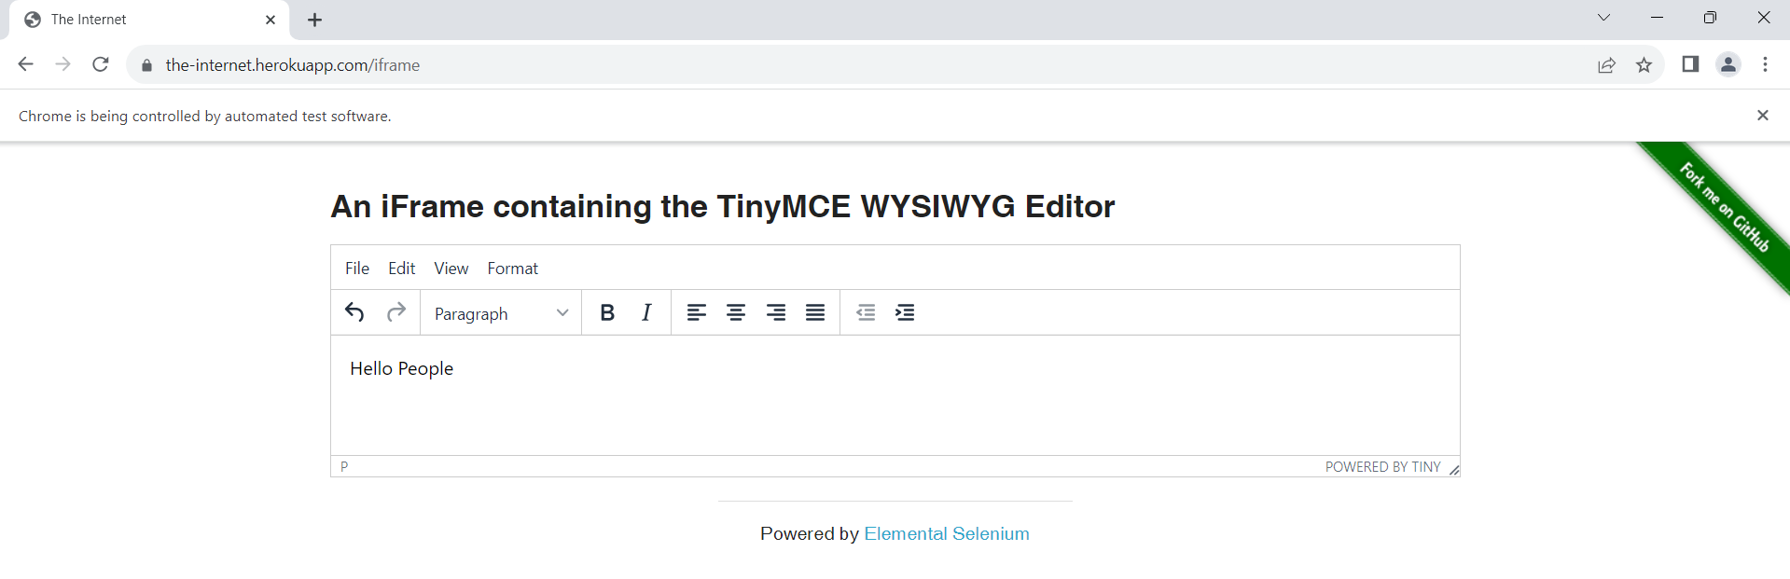

Screenshot showing switching inside iframe and entering the data

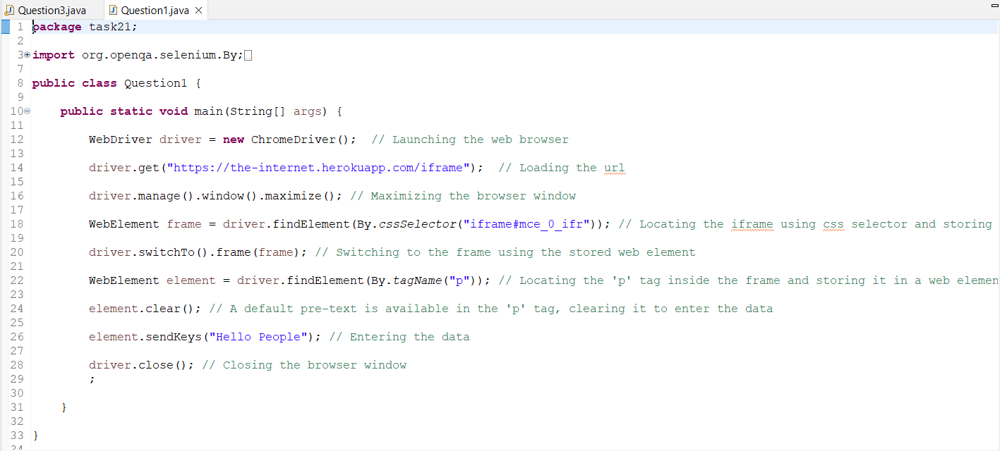

Question 1 source code

Question 2: Window handling

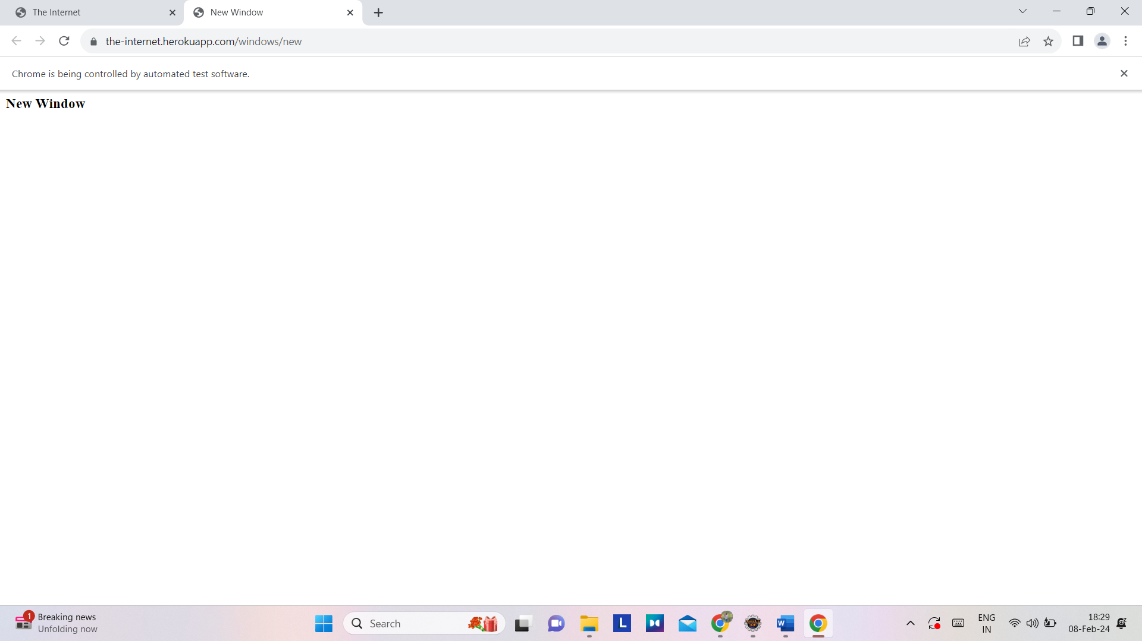

Screenshot showing browser window with 2 tabs

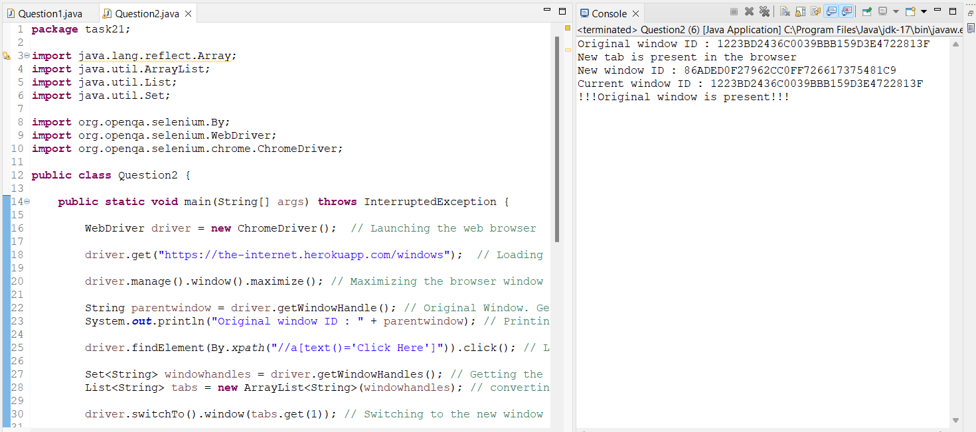

Question:2 – console output

Question:3 – Handling nested frames

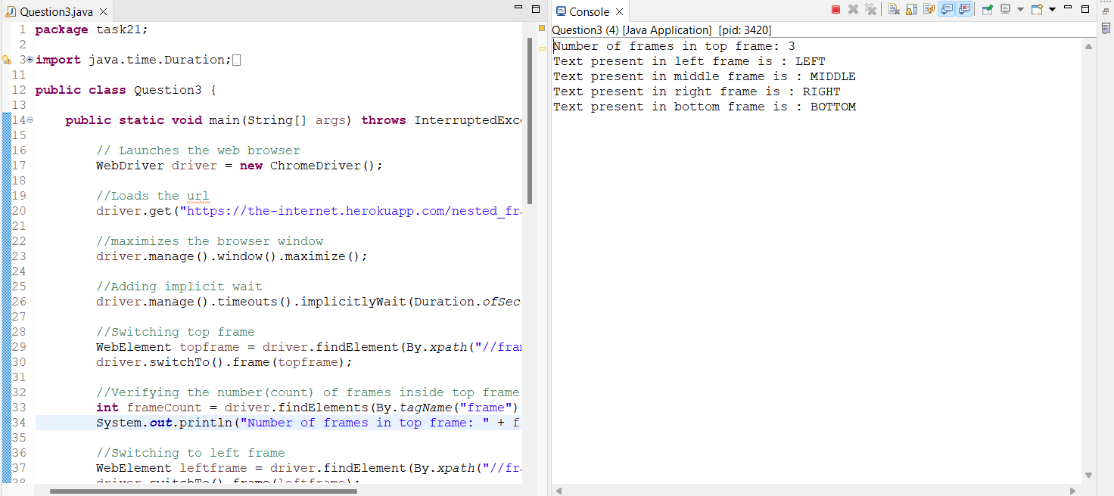

Q3 console output